# Avocado Project

**Here is a 2000-word blog article on the Avocado Project:**

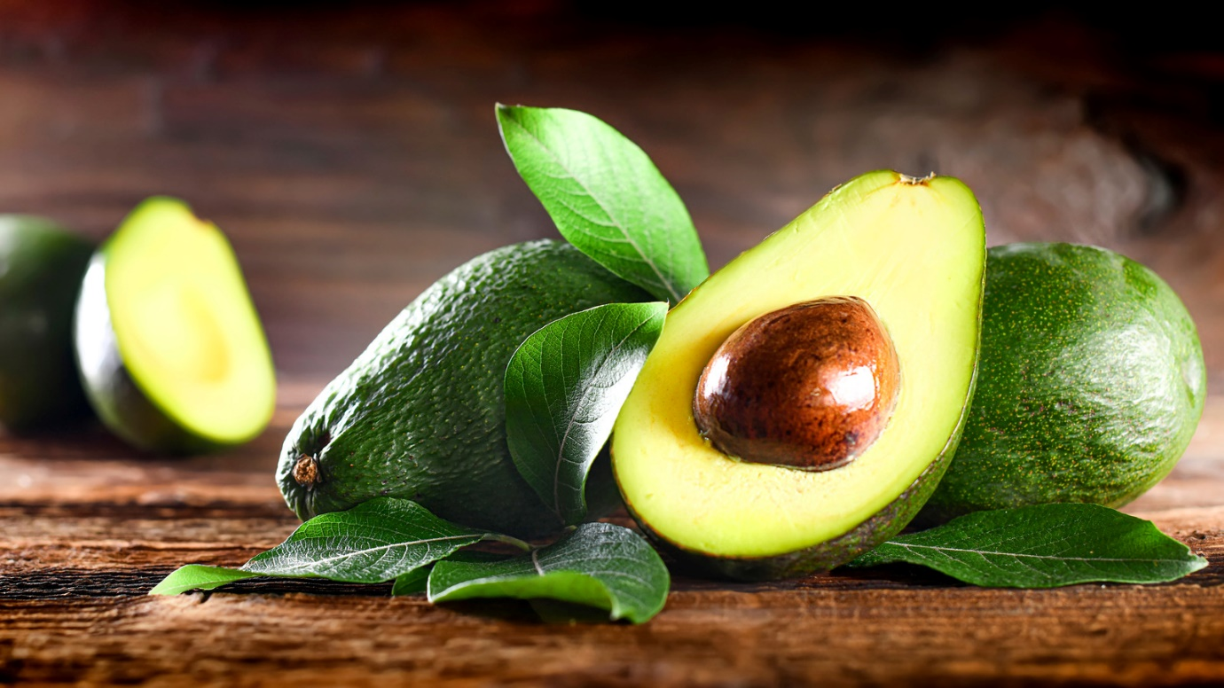

**Project Description This data was downloaded from the Hass Avocado Board website in May of 2018 & compiled into a single CSV. The table below represents weekly 2018 retail scan data for National retail volume (units) and price. Retail scan data comes directly from retailers’ cash registers based on actual retail sales of Hass avocados. Starting in 2013, the table below reflects an expanded, multi-outlet retail data set. Multi-outlet reporting includes an aggregation of the following channels: grocery, mass, club, drug, dollar and military. The Average Price (of avocados) in the table reflects a per unit (per avocado) cost, even when multiple units (avocados) are sold in bags. The Product Lookup codes (PLU’s) in the table are only for Hass avocados. Other varieties of avocados (e.g. greenskin) are not included in this table.**

**Problem Definition**

**In recent years, avocados have become a staple in many households, prized for their nutritional value and versatility in cooking. But have you ever wondered about the market dynamics behind this trendy fruit? Our project delves into the world of avocado retail sales, exploring weekly data from 2018 to uncover trends, patterns, and insights.**

**Our dataset, compiled from the Hass Avocado Board website, comprises national retail volume and price data, aggregated from various channels including grocery, mass, club, drug, dollar, and military outlets. With over 50,000 data points, our analysis offers a comprehensive view of the avocado market.**

**Some key findings from our analysis include:**

**- Average price fluctuations throughout the year, influenced by factors like seasonality and supply chain dynamics**

**- Regional variations in retail volume and price, reflecting differing consumer preferences and market conditions**

**- Correlations between price and volume, indicating the responsiveness of consumers to price changes**

**Our project demonstrates the power of data analysis in understanding market trends and consumer behavior. By exploring the avocado market through a data-driven lens, we can gain valuable insights for stakeholders across the supply chain, from farmers to retailers. Whether you're an industry professional or simply an avocado enthusiast, our findings offer a fascinating glimpse into the world of this beloved fruit.**

**- Introduce the goal of the project: to analyze and forecast avocado retail sales and prices**

**- Explain the importance of understanding market trends and consumer behavior in the avocado industry**

**- Became aware of the Python plotly module, which allowed to create incredibly interactive graphs. Plotted various charts, including line, scatter, bar, and scatterplots, and noted the analysis.**

**Data Analysis**

- **Describe the dataset: weekly retail scan data for 2018, including national retail volume and price**

**- Discuss data quality and any necessary cleaning or handling procedures**

**- Perform exploratory data analysis (EDA) to identify trends, correlations, and outliers**

**EDA Conclusion Remarks**

**- Summarize key findings from the EDA, including any notable patterns or correlations**

**- Highlight potential challenges or limitations in the data**

**Pre-processing Pipeline**

**- Outline the steps taken to prepare the data for modeling, such as:**

**- Handling missing values**

**- Normalizing or scaling the data**

**- Feature engineering (e.g., creating new features from existing ones)**

**Building Machine Learning Models**

**- Describe the machine learning models used to predict avocado sales and prices (e.g., linear regression, decision trees etc)**

**- Discuss model evaluation metrics (e.g., mean absolute error, mean squared error) and hyperparameter tuning**

**- Present the results of the model training and evaluation**

**Some key findings from our analysis include:**

**- Average price fluctuations throughout the year, influenced by factors like seasonality and supply chain dynamics**

**- Regional variations in retail volume and price, reflecting differing consumer preferences and market conditions**

**- Correlations between price and volume, indicating the responsiveness of consumers to price changes**

**Concluding Remarks**

**- Summarize the key findings and insights from the project**

**- Discuss the implications of the results for the avocado industry and potential applications**

**- Suggest future directions for research and improvement.**

**Thank You,**

**Neha Pothiwal**

**Batch-DS2401**